**DAILY ONLINE ACTIVITIES SUMMARY**

|  |  |  |  |  |  |  |  |  |
| --- | --- | --- | --- | --- | --- | --- | --- | --- |
| **Date:** | **26/06/20** | | | | | **Name:** | **Gulam Rabbani** | |
| **Sem & Sec** | **4th Sem “B” Section** | | | | | **USN:** | **4AL18CS099** | |
| **Online Test Summary** | | | | | | | | |
| **Subject** | | **Not conducted** | | | | | | |
| **Max. Marks** | | **0** | | **Score** | | | **0** | |
| **Certification Course Summary** | | | | | | | | |
| **Course** | [The Complete Front-End Web Development Course!](https://www.udemy.com/course/front-end-web-development/) | | | | | | | |
| **Certificate Provider** | | | **Udemy** | | **Duration** | | | **15:00:00** |
| **Coding Challenges** | | | | | | | | |
| **Problem Statement: 1 Python program** | | | | | | | | |
| **Status: Executed** | | | | | | | | |
| **Uploaded the report in GitHub** | | | | | **Yes** | | | |
| **If yes Repository name** | | | | | **https://github.com/alvas-education-foundation/gulam_rabbani/tree/master/daily_progress** | | | |
| **Uploaded the report in slack** | | | | | **Yes** | | | |
|  | | | | |  | | | |
|  | | | | |  | | | |

Online Test Details: (Attach the snapshot and briefly write the report for the same)

No examination

Certification Course Details: (Attach the snapshot and briefly write the report for the same)

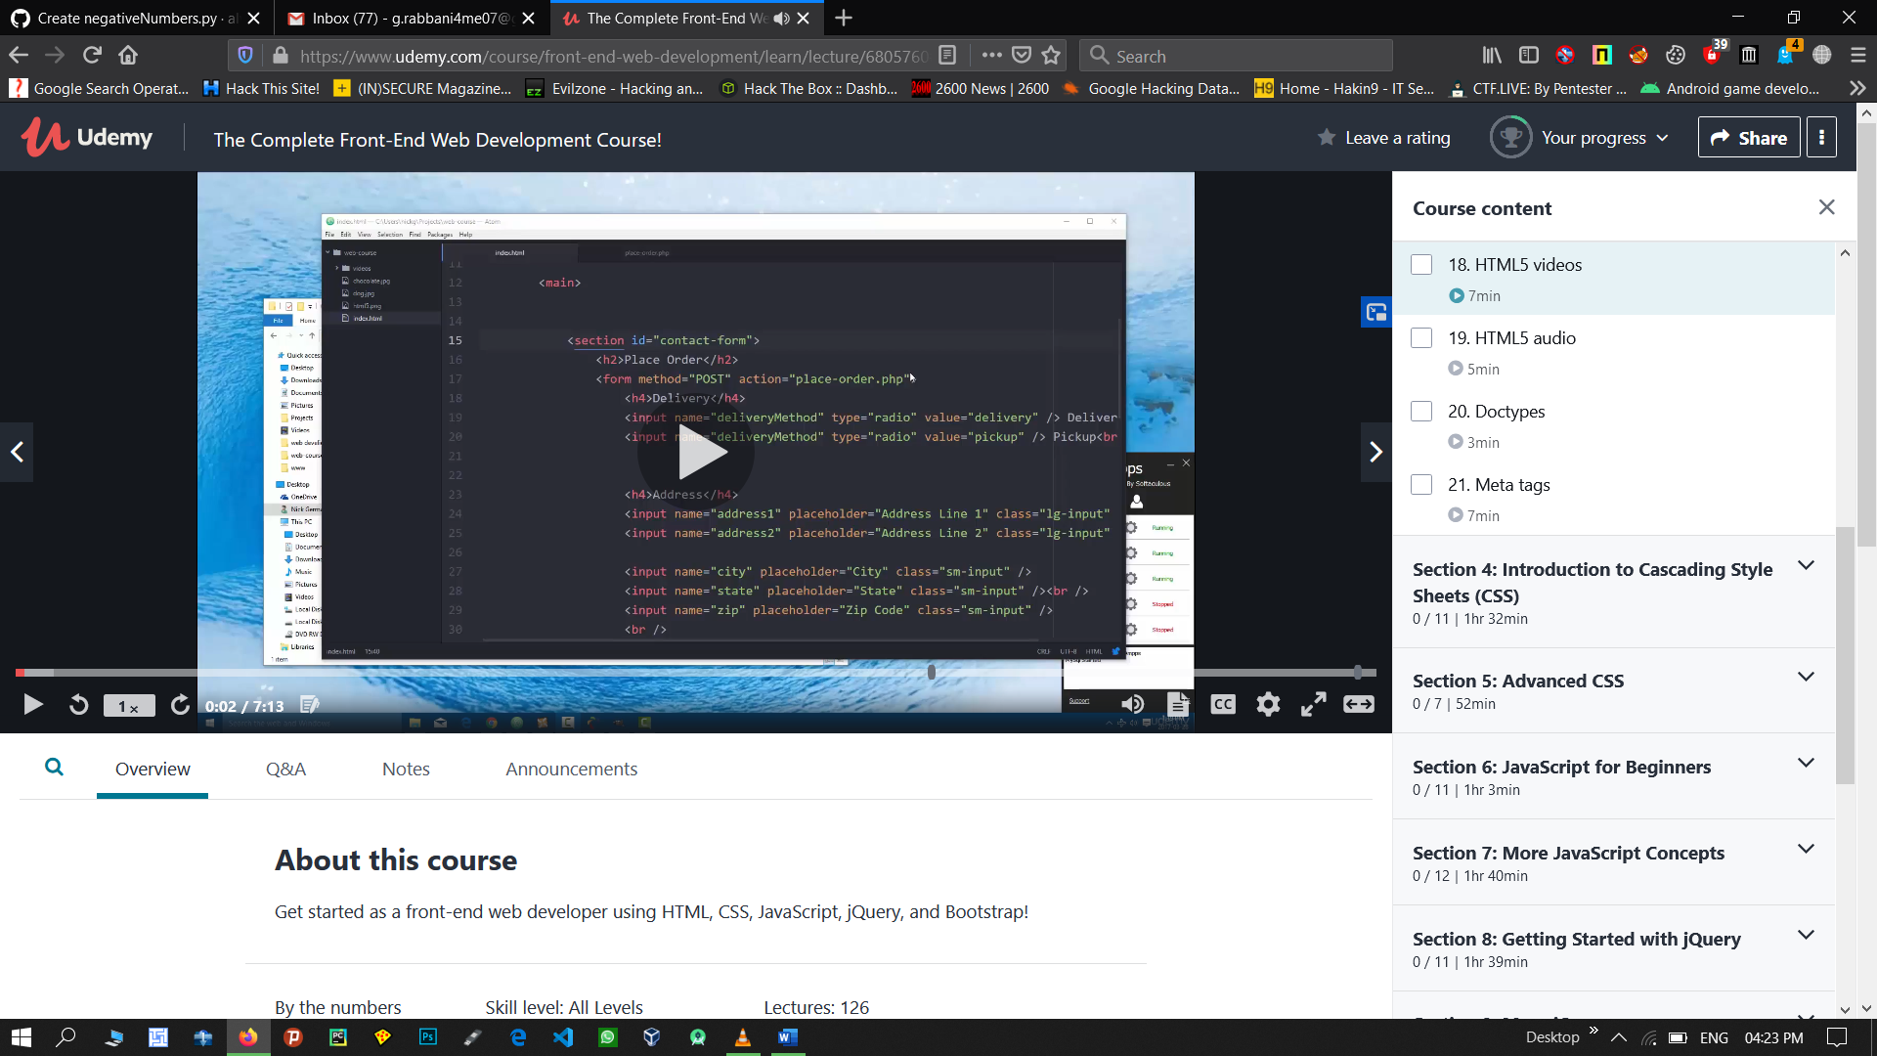

**What you’ll learn**

* Build a simple HTML text site
* Style web pages using CSS
* Program websites with JavaScript
* Build a Pipboy using Bootstrap
* Build and publish a Google Chrome Extension

Coding Challenges Details: (Attach the snapshot and briefly write the report for the same)

